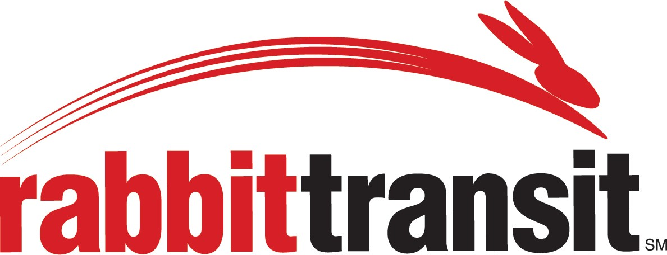
Susquehanna Regional Transportation Authority
Service ▪ Safety ▪ Stewardship

SUSQUEHANNA REGIONAL TRANSPORTATION AUTHORITY TITLE VI I CIVIL RIGHTS COMPLAINT FORM

Title VI of the 1964 Civil Rights Act requires that “No person in the United States shall, on the ground of race, color or national origin, be excluded from participation in, be denied the benefits of, or be subjected to discrimination under any program or activity receiving federal financial assistance.” Please call for our policy or visit our website at www.rabbittransit.org.

If you feel you have been discriminated against in transit services, please print and complete the following form, sign (signature in Section 4 required) and return to:

rabbittransit (Susquehanna Regional Transportation Authority) ATTN: Sherry Welsh, SRTA Compliance Officer
415 Zarfoss Drive
York, PA 17404
Telephone - (717) 849-0731
Fax - (717) 846-1232
Section I:
Please print CLEARLY

- Name (Complainant):

- Home Address:

City, State, Zip Code:

- Telephone Number: Email Address

Section 2:

- Are you filing this complaint on your own behalf? □ Yes □ No (If you answered “yes” to this question, please go to Section III.

- If you answered “no” to question 6, please describe your relationship to the person (Complainant) for whom you are filing and why you are filing for a third party:

- Have you obtained permission of the aggrieved party (Complainant) to file this complaint on his or her behalf? □ Yes □ No

Section 3:
- Date of Incident:

- If applicable, name of person(s) who allegedly discriminated against you:

- Discrimination based on (please check all that apply): □ Race □ Color □ National Origin
□ Other, please describe

- Please provide a brief explanation of the incident and how you feel you were discriminated against including how you feel others may have been treated differently than you.

- Please list addresses and phone numbers of all witnesses’ names or others we can contact to support or clarify your complaint.

Name Address Phone Number

- What type of corrective action would you like to see taken?

- Please attach any documents you have which support the allegation. Attached □ Yes □ No

- Have you previously filed a Title VII complaint with Susquehanna Regional Transportation Authority?
□ Yes □ No If yes, please provide date of incident.
Section 4:
Signature: Date of Filing:

Print your name:

Please note: Susquehanna Regional Transportation Authority cannot accept your complaint without a signature.

