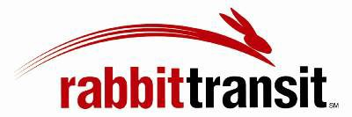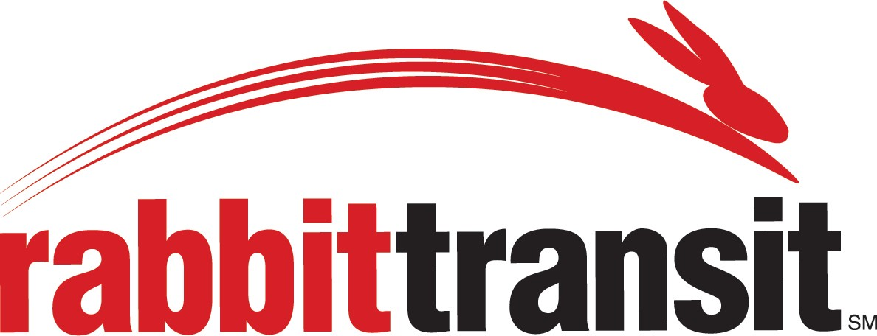

Paratransit/Shared Ride Ticketless Fares Order Form

Please provide information below for the Client whose balance is to be credited.

Client Name:

Birthdate/ID #:

Address:

Phone #:

Amount to be credited:

Please make checks or money orders payable to: rabbittransit
Mail this form and your payment to:
rabbittransit
415 North Zarfoss Drive York, PA 17404

Funds will typically be available for use within (1) business day after receipt of payment. If you have any questions, please contact our Customer Service Department at (717) 846-RIDE (7433) or
1-800-632-9063. Thank you.

