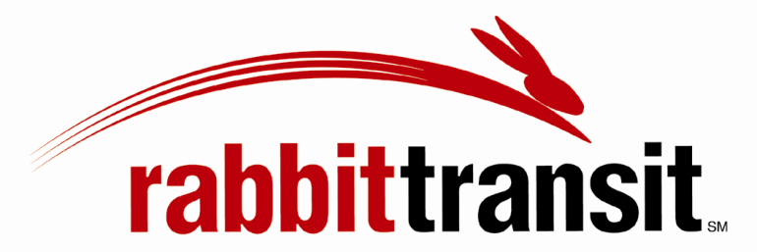
PROCEDURE ON REASONABLE MODIFICATION/ACCOMMODATIONS

Procedure Effective Date: July 13, 2015
Updated: March 10, 2017
It is rabbittransit’s policy to make reasonable modifications to its policies, practices, or procedures when requested to do so by qualified individuals with disabilities when such accommodations are necessary to avoid discrimination based on disability.
Requests for accommodations will be considered on a case-by-case basis and may be denied on one or more of the following grounds:
- Granting the request would fundamentally alter the nature of rabbittransit’s service, programs, or activities;
- Granting the request could create a direct threat to the health or safety of the requestor or others;
- Granting the request would create an undue financial or administrative burden for the Agency; or
- Without such modification, the individual with a disability is otherwise able to fully use rabbittransit’s services, programs, or activities for their intended purpose.
In determining whether to grant a requested modification, rabbittransit will be guided by the provisions of United States Department of Transportation at 49 CFR Appendix E to Part 37.169.
When choosing among alternatives for accommodations, rabbittransit will give priority to those methods that offer services, programs and activities to qualified individuals with disabilities in the most integrated setting appropriate for the needs of the individual(s) with disabilities. In any case in which rabbittransit denies a request for an accommodation, rabbittransit will attempt to ensure that the individual with a disability receives the services or benefits provided by rabbittransit by other means that comport with this policy.
PROCESS FOR REQUESTING MODIFICATIONS/ACCOMMODATIONS FOR INDIVIDUALS WITH DISABILITIES
Requests for modifications of rabbittransit’s policies, practices, or procedures to accommodate an individual with a disability may be made either in advance or at the time of the transportation service. rabbittransit is best able to address and accommodate a request when customers make their requests for modifications in advance. The process for making a request is as follows:
Advance Requests:
When making a request, please thoroughly describe what is needed in order for you to use the service, and why this assistance is necessary.
Whenever feasible, a request for modification to rabbittransit’s service should be made in advance before rabbittransit is expected to provide the service. rabbittransit will review your request, and will make every effort to communicate in advance whether or not the requested modification can be made.
If the modification is not made, rabbittransit will provide the reason for the denial of the request. Requests may be denied on one or more of the following grounds:
- Granting the request would fundamentally alter the nature of rabbittransit’s service, programs, or activities;
- Granting the request could create a direct threat to the health or safety of the requestor or others;
- Granting the request would create an undue financial or administrative burden for the Agency; or
- Without such modification, the individual with a disability is otherwise able to fully use rabbittransit’s services, programs, or activities for their intended purpose.
Requests may be made through the following means:
Call the rabbittransit call center at (717)-846-7433 and ask for mobility planning.
You may also submit a written request via email at info@rabbittransit.org, please state reasonable modification in the subject line.
Same Day Requests:
- When a request for modification cannot practicably be made and determined in advance, you may make a request on the same day, at the time of, or during service.
- You should make your request to the operator of your bus.
- Please describe in detail what accommodation you require and why it is necessary in order to use the service.
- Operators may grant a request if such request is reasonable and meets the requirements of the Agency’s policy.
- If an Operator is unsure if the request can be granted or declined, she/he is required to consult with rabbittransit dispatch to receive direction.
Requests may be denied on the following grounds:
- Granting the request would fundamentally alter the nature of rabbittransit’s service, programs, or activities;
- Granting the request could create a direct threat to the health or safety of the requestor or others;
- Granting the request would create an undue financial or administrative burden for the Agency; or
- Without such modification, the individual with a disability is otherwise able to fully use rabbittransit’s services, programs, or activities for their intended purpose
- Operator availability may be very limited when providing service and if the request would require extended consideration, we may not be able to grant your request immediately, and you may be encouraged to submit a written request for further consideration in future trips.
rabbittransit’s ability to grant the requested modifications may vary by route, day of travel, time of day, or other circumstances. For example, while a request may be able to be granted in one instance, that same request may be denied in another instance if granting the request would fundamentally alter the nature of the service or create a safety threat, or if the request is not a functional necessity.
In the case of a denial of a request, rabbittransit will take, to the maximum extent possible and in compliance with its policies, any other appropriate actions to ensure you receive service.
Designated employee for compliance: rabbittransit has designated the Director of Mobility Services, as the employee responsible for ensuring compliance of this policy and for administering the prompt and equitable resolution of any related complaints. Contact information is as follows:
Mobility Planning: 717-846-7433, Option #3. Or by email at info@rabbittransit.org.
Complaint Process and Contact Information: Complaints regarding the administration of or compliance with this policy shall be made in writing either by letter or email addressed to the Agency’s Civil Rights Officer, or by completing and returning the Title VI or Discrimination Complaint Form found at: http://rabbittransit.org/Diversity/CivilRights.aspx
All complaints will be handled in accordance with rabbittransit’s Title VI and Discrimination Complaint Process found at http://rabbittransit.org/Diversity/CivilRights.aspx. rabbittransit will make every effort to make a prompt and equitable resolution of any complaint. The Agency’s response to any Title VI complaint will be in writing and will include the Agency’s decision and the reason(s) therefore.

